RSA-008 Metrology Results:

TS2 & Simulation

PZ Takacs 2017.03.29

rev. 2017.07.25 with R.A. Coles

# Introduction

This report presents the measurements of absolute height on RSA-008 made at TS2 with the OGP machine and compares those results to the simulated RSA height generated by the simulation program created by R. Coles. The results of the simulation appear to agree very well with the measured data. It is anticipated that this program will prove to be a useful tool in allocating sensors to rafts to produce RSAs.

# Early data analysis

The results in this section were presented in an earlier version of this report. The analysis code at the time did not include the correction factors for the sag of the MF03 fixture and the non-ideal tolling ball radius. Hence, all of the absolute height values are low by approximately 3 µm. The results as presented earlier are as follows:

Raw input data shows RSA CCD surface at top level, Golden Raft (ECM-005) at mid-level, and the three balls at the bottom.

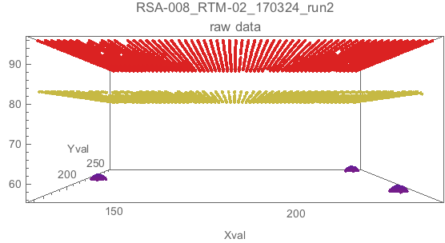

Flatness of RSA surface. LSF plane has been subtracted.:

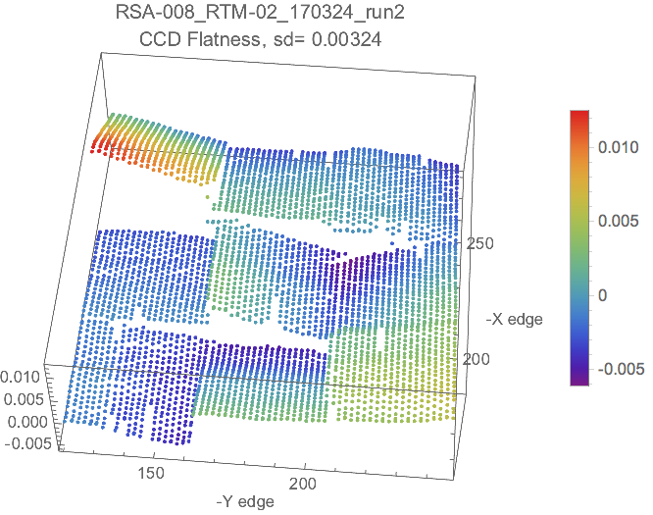

Map of sensor slots for RSA assembly. View is same orientation as above measured plot.

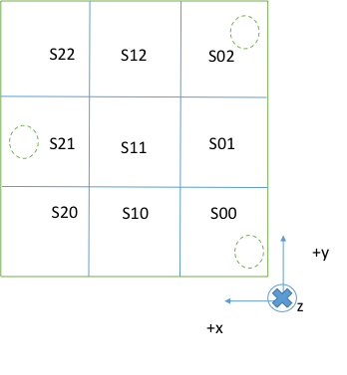

The high sensor is in slot S22.

|  |  |  |  |  |  |  |
| --- | --- | --- | --- | --- | --- | --- |
|  |  |  |  |  |  |  |
| **Baseplate S/N : ECM-018** | |  |  |  |  |  |
| **Vendor:** | e2v |  |  |  |  |  |
| **Z-Nom:** | 13.000 |  |  |  |  |  |
|  |  |  |  |  |  |  |
| **Slot  Region** | **Base Plate Local Difference from Spec (29.795mm)** | **Suggested Sensor for  Slot Location** | **Sensor Height Measured  By LSST** | **Sensor Height Difference  Relative to Vendor Z-Nom** | **Combined Height Difference from 42.795mm Nominal Height** | **High/Low  Points** |
| S00 | -0.002 | e2v-220 | 13.001 | 0.001 | -0.001 |  |
| S01 | -0.002 | e2v-239 | 13.000 | 0.000 | -0.002 |  |
| S02 | -0.003 | e2v-154 | 13.003 | 0.003 | 0.000 |  |
| S10 | 0 | e2v-165 | 12.995 | -0.005 | -0.005 | Low |
| S11 | -0.002 | e2v-130 | 13.000 | 0.000 | -0.002 |  |
| S12 | -0.003 | e2v-153 | 13.005 | 0.005 | 0.002 | High |
| S20 | 0.003 | e2v-163 | 12.993 | -0.007 | -0.004 |  |
| S21 | -0.001 | e2v-216 | 12.998 | -0.002 | -0.003 |  |
| S22 | -0.003 | e2v-252 | 13.005 | 0.005 | 0.002 | High |

Absolute height of RSA surface relative to 3-ball datum plane. The nominal height plane for a warm e2V RSA is shown at Z = 42.795mm. Note that the majority of the surface height is below Znom.

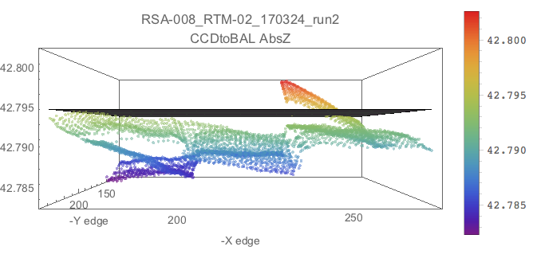

## Summary statistics for flatness and absolute height.

Specification for flatness is PV100flat < 20µm. Result shows PV100flat = 18.6µm

Summary statistics for RTM data file: RSA-008_RTM-02_170324_run2.

Report generated Wed 29 Mar 2017 18:10:06

Notebook version: 3 level BAL RBP CCD planes 170328.nb

Last modified: Wed 29 Mar 2017 18:07:30

## Flatness

Flatness PV100 = -18.6399 <20[µm]

|  |  |
| --- | --- |
| Quantiles |  |
| 1. | 12.4916 |
| 0.995 | 11.1959 |
| 0.99 | 10.2979 |
| 0.975 | 8.41555 |
| 0.75 | 1.73132 |
| 0.5 | -0.836556 |
| 0.25 | -2.3503 |
| 0.025 | -4.42045 |
| 0.01 | -4.90018 |
| 0.005 | -5.1666 |
| 0. | -6.14829 |

## Absolute Height

**Absolute Heigh**t relative to Znom (= 42.795 mm).

Mean Z = 42.790

Median Z = 42.7902

AbsZ PV100 = 20.4734 [<20µm]

AbsZ Quantiles: RSA-008_RTM-02_170324_run2

CCDtoBAL AbsZ Quantiles: Znom = 42.795

|  |  |  |
| --- | --- | --- |
|  | AbsZ wrt BAL datum | Height wrt Znom |
|  | Z[mm] | Z – 42795 [µm] |
| 1. | 42.8026 | 7.63708 |
| 0.995 | 42.8016 | 6.56472 |
| 0.975 | 42.7993 | 4.25994 |
| 0.75 | 42.7921 | -2.90734 |
| 0.5 | 42.7902 | -4.79573 |
| 0.25 | 42.7873 | -7.6728 |
| 0.025 | 42.7838 | -11.2218 |
| 0.005 | 42.7828 | -12.1577 |
| 0. | 42.7822 | -12.8363 |

Cumulative height fraction: Fraction of surface below given height

(Znom = 42.795)

|  |  |
| --- | --- |
| Z[mm] | Fraction |
| 42.803 | 1. |
| 42.802 | 0.997072 |
| 42.801 | 0.991705 |
| 42.8 | 0.983411 |
| 42.799 | 0.9717 |
| 42.798 | 0.95877 |
| 42.797 | 0.946084 |
| 42.796 | 0.934374 |
| 42.795 | 0.923884 |
| 42.794 | 0.904367 |
| 42.793 | 0.860698 |
| 42.792 | 0.732618 |
| 42.791 | 0.581117 |
| 42.79 | 0.478653 |
| 42.789 | 0.40766 |
| 42.788 | 0.343986 |
| 42.787 | 0.196877 |
| 42.786 | 0.141986 |
| 42.785 | 0.0861186 |
| 42.784 | 0.0351305 |
| 42.783 | 0.00634301 |

Fraction above max tolerance (Znom+10µm=42.805) = 0

Fraction below min tolerance (Znom-10µm=42.785) = 0.0861186

See that the bulk of the surface sits below the Znom 42.795mm level. The mean Z is 42.790mm, with 8.6% of the surface lying below the lower tolerance limit of 42.785mm.

# Compare TS2 RSA measurement to AbsZ simulation

The previous section’s data analysis did not have the corrections for metrology fixture deflection and actual ball radius applied. These corrections raise the absolute z height values by about 3 microns. The run2 data file was re-analyzed and is shown below. The measured data is compared with the simulated surface height profile which is generated by using the measured sensor absolute height data with the measured raft baseplate height profile. The measured sensor points are inserted into the appropriate raft baseplate slots and the resultant data set is analyzed as if it were a real RSA measurement.

The comparisons below show the absolute height map of each surface with the TS2 measurement in the upper frame and the simulation surface in the lower frame. Surface density plots are shown first, then the histogram of the absolute heights, and then the summary statistics for each data set.

Comparing the surface plots, one can see that the two different methods look qualitatively remarkably similar, except for the S12 sensor that shows up higher in the simulation. The mean Z value for the TS2 data is 42.794mm and is 42.799mm for the simulation. The PV100 spread is slightly more for the TS2 data, 20.3µm vs. 17.9µm, but the simulation has 3.8% exceeding the maximum height tolerance while the TS2 measurements only has 0.6% exceeding that threshold. Neither of the data sets has points exceeding the lower height tolerance, in contrast to the uncorrected measurements in the first section above.

Compare TS2 RSA AbsZ measurement (upper) to RSA AbsZ simulation data (lower)

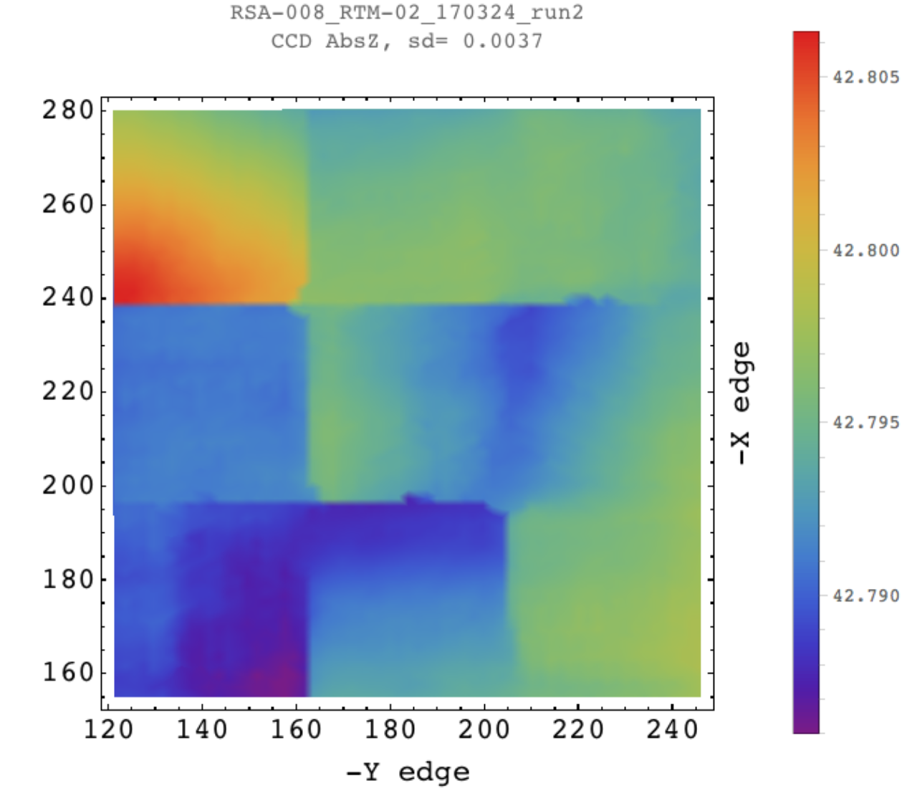

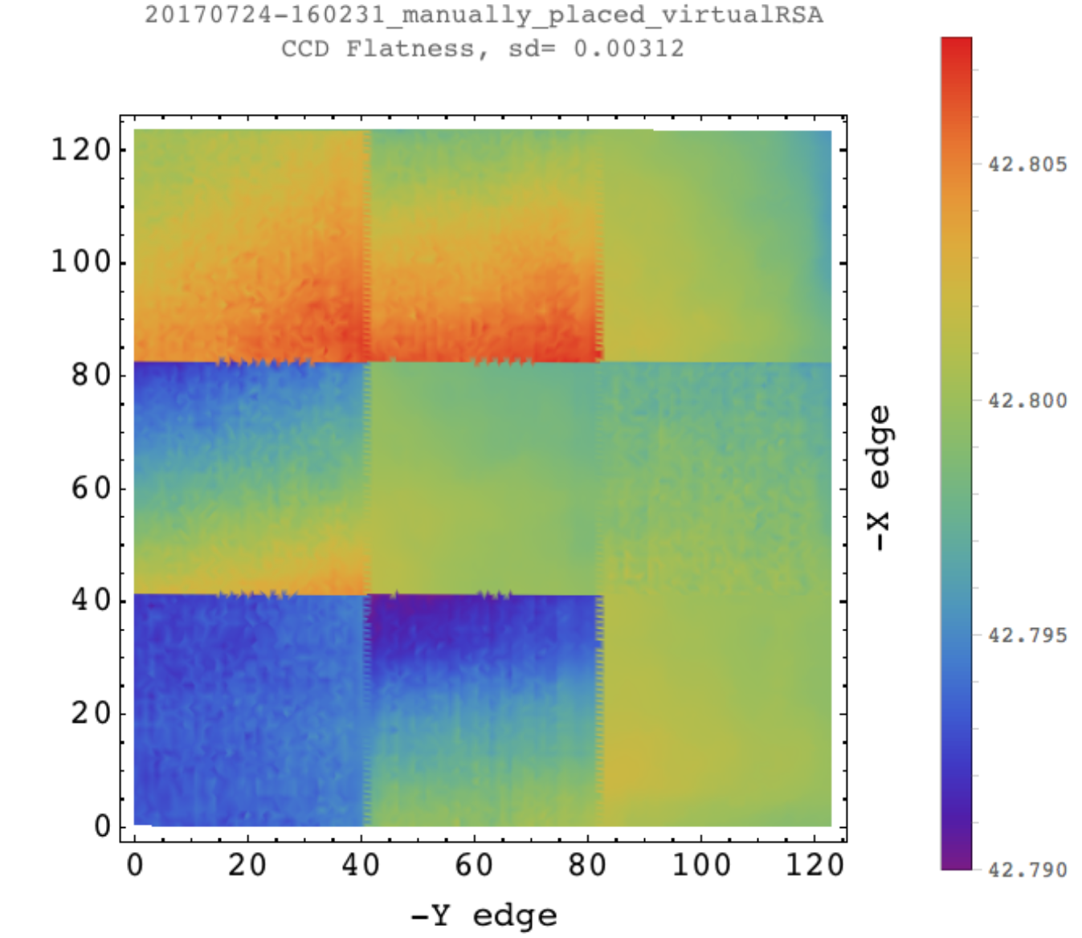

Histograms of RSA AbsZ for TS2 data (upper) and RSA AbsZ simulation data (lower).

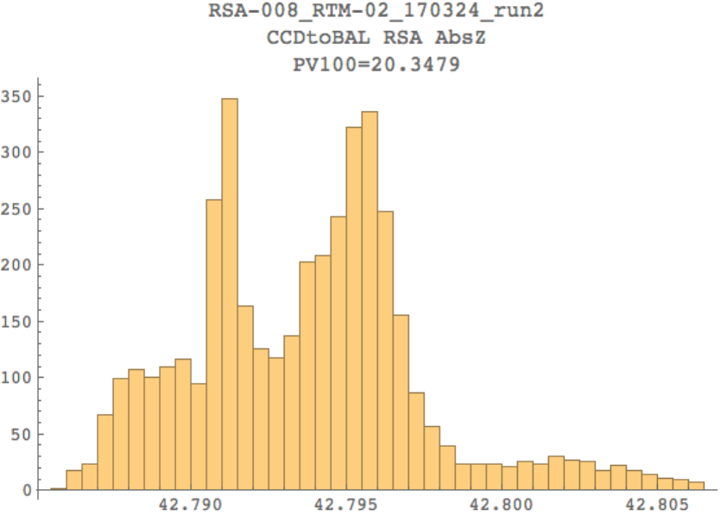

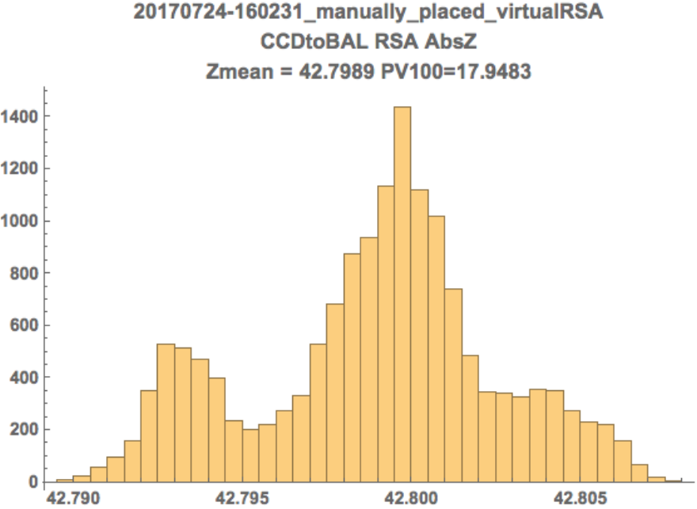

**Summary statistics for RSA TS2 measurement data file:**

RSA-008_RTM-02_170324_run2.

Height correction factors applied:

Ball diameter offset = 0.000707 mm

MF03 sag from weight of RSA = 0.003 mm

Flatness PV100 = 18.6405 µm [Tol<20µm]

Flatness Quantiles [µm]

1. 12.491

0.995 11.1793

0.99 10.2973

0.975 8.4149

0.75 1.73526

0.5 -0.837246

0.25 -2.35535

0.025 -4.43261

0.01 -4.90482

0.005 -5.1575

0. -6.14954

Absolute Height relative to ZnomCCD (= 42.795 mm):

Mean Z = 42.7937 mm

Median Z = 42.7939 mm

StdDev = 0.00369807 mm

AbsZ PV100 = 20.3479 µm [Tol<20µm]

Fraction above max tolerance (ZnomCCD+10µm= 42.805) = 0.00683093

Fraction below min tolerance (ZnomCCD-10µm= 42.785) = 0

Fraction of surface below given height:

42.807 1.

42.806 0.998292

42.805 0.993169

42.804 0.985606

42.803 0.975848

42.802 0.963162

42.801 0.950232

42.8 0.93901

42.799 0.927787

42.798 0.912662

42.797 0.877531

42.796 0.779458

42.795 0.618931

42.794 0.508905

42.793 0.425958

42.792 0.366431

42.791 0.24201

42.79 0.156136

42.789 0.101244

42.788 0.0507441

42.787 0.0102464

42.786 0.000243962

AbsZ Quantiles:

RSA-008_RTM-02_170324_run2

CCDtoBAL AbsZ Quantiles. Includes fixture correction 0.003707mm

with ZnomCCD=42.795 subtracted

1. 42.8063 11.3437

0.995 42.8053 10.2728

0.975 42.803 7.96258

0.75 42.7958 0.807959

0.5 42.7939 -1.08356

0.25 42.791 -3.96598

0.025 42.7875 -7.54034

0.005 42.7865 -8.48769

0. 42.786 -9.00427

Report generated Mon 24 Jul 2017 15:26:35

Notebook version: RSA AbsZ wBAL RBP CCD 170724.nb

Last modified: Mon 24 Jul 2017 15:08:49

**Summary statistics for RSA simulated data file:**

20170724-160231_manually_placed_virtualRSA.

Flatness PV100 = 15.5645 µm [Tol<20µm]

Flatness Quantiles [µm]

1. 7.50356

0.995 6.64936

0.99 6.3745

0.975 5.8665

0.75 2.38527

0.5 -0.016414

0.25 -2.42018

0.025 -5.8613

0.01 -6.58661

0.005 -6.99103

0. -8.06097

Absolute Height relative to ZnomRSA (= 42.7952 mm):

Mean Z = 42.7989 mm

Median Z = 42.7994 mm

AbsZ PV100 = 17.9483 µm [Tol<20µm]

Fraction above max tolerance (ZnomRSA+10µm= 42.8052) = 0.0386805

Fraction below min tolerance (ZnomRSA-10µm= 42.7852) = 0

Fraction of surface below given height:

42.808 1.

42.807 0.998836

42.806 0.984541

42.805 0.955369

42.804 0.915201

42.803 0.871151

42.802 0.826973

42.801 0.748124

42.8 0.609961

42.799 0.444049

42.798 0.326843

42.797 0.248771

42.796 0.209767

42.795 0.182665

42.794 0.141915

42.793 0.0782665

42.792 0.0217982

42.791 0.00556274

42.79 0.000452781

AbsZ Quantiles:

20170724-160231_manually_placed_virtualRSA

CCDtoBAL AbsZ Quantiles.mm

and with ZnomRSA =42.7952 subtracted

1. 42.8077 12.4672

0.995 42.8065 11.3092

0.975 42.8056 10.4404

0.75 42.801 5.8126

0.5 42.7994 4.188

0.25 42.797 1.8234

0.025 42.7921 -3.1267

0.005 42.7909 -4.2695

0. 42.7897 -5.4811

Report generated Tue 25 Jul 2017 14:33:48

Notebook version: RSA AbsZ wBAL RBP CCD 170713sim.nb

Last modified: Fri 21 Jul 2017 16:10:34